Innovations Academy — Material Revision Petition
Enrollment Increase & New Adjacent Facility (5520 Ruffin Rd)
Board-Ready Narrative Outline

Authorizer: San Diego Unified School District (SDUSD)
Date: September 2025
Contact: Executive Director, Innovations Academy

I. Executive Summary
Requested Action: Approve a material revision to increase total enrollment by approximately 200 students and to operate a second, adjacent building at 5520 Ruffin Rd to support K–8, TK, and Homeschool programs beginning Fall 2026.
- Current enrollment: ~434 K–8 + 65 Homeschool.
- Target enrollment: ~580 total (incl. 100 Homeschool and 30 TK).
- New facility: ~17k+ sq ft, recently renovated, move‑in ready; capacity ~250–300 students.
- Financing: ~$6.9M acquisition via partner; 20‑year NNN lease; CPI escalator (3% floor).
- Key conditions: Charter renewal; Conditional Use Permit (CUP) and E‑Occupancy; potential SB740 eligibility.

II. Background & Mission
Innovations Academy is a TK–8 inquiry‑based project charter school authorized by SDUSD. Opened in 2008, renewed in 2012 and 2018, with a subsequent renewal planned in 2026. The mission centers on self‑expression, compassionate connection, and purposeful learning.
The current 5454 Ruffin Rd campus (~77k sq ft) houses K–8 and the Homeschool program; capacity has been reached, constraining growth for TK and Homeschool without adversely impacting K–8 classroom availability.

III. Rationale for Revision
- Demand: Waitlists and community demand warrant additional seats.
- Programmatic Fit: Expansion preserves class sizes (approx. 25 pupils/class K–6; 7–8 maintained with appropriate staffing) and allows a modest TK program.
- Site Adjacency: The adjacent 5520 Ruffin Rd site enables operational efficiency (shared leadership, support services, and scheduling) while minimizing transportation burdens.

IV. Facilities Plan
Site 1 (5454 Ruffin Rd): Core K–8 program continues; reconfiguration to optimize classroom use.
Site 2 (5520 Ruffin Rd): TK, Homeschool, and overflow K–8 classrooms; recently renovated with >$5M improvements; building size ~17k+ sq ft.
- Occupancy & Permits: CUP and E‑Occupancy approvals prior to student use.
- Compliance: ADA access, fire/life‑safety, sanitation, parking/traffic plan.
- Capacity Calculations: 250–300 students supported with typical classroom loading (~25 students/class) and dedicated support spaces.

V. Educational Program & Staffing
The inquiry‑based program will operate coherently across both facilities. Instructional materials, assessment systems, and SEL supports remain consistent. Staffing scales proportionally with enrollment to maintain class size goals and student support.
- Hiring Plan: Additional teachers, aides, SPED/ELL staff, counseling, office/admin support, custodial and site supervision.
- Class Size Commitments: Kindergarten ≤31 average (≤33 max); Grades 1–3 ≤30 average (≤32 max); Grades 4–8 aligned to established caps/ratios and campus capacity.
- Professional Learning: New‑hire onboarding and ongoing PD aligned to IA pedagogy.

VI. Enrollment, Fiscal, and Facilities Economics
Targeted Enrollment Path and Break‑Even
- Breakeven target ~578 students by SY 2026/27 to achieve 1.2x rent coverage.
- Growth path illustrates 580 total with TK (30) and Homeschool (100).
Facility Financing & Lease Terms (Indicative)
- Acquisition financing approx. $6.9M; purchase price approx. $6.7M; closing ~$70k; improvements ~$150k.
- 20‑year NNN lease; 4×5‑year renewals; CPI escalator with 3% floor.
- Illustrative Rent Schedule: Year 1 ~$622,800 total (avg. $51,900/mo); Year 2 ~$641,484; Year 3 ~$660,729. Fiscal‑year totals: FY26 $311,400 (partial year), FY27 $632,142, FY28 $651,106.
SB740 Consideration
- Preliminary review suggests potential SB740 eligibility for rent subsidy (subject to confirmation).
Three‑Year Pro Forma (Summary Requirements)
- ADA‑based revenue with conservative attendance assumptions.
- New facility lease plus marginal operating and staffing costs.
- Reserves policy compliance and monthly cash‑flow projections.

VII. Governance, Oversight & Accountability
- Board oversight of finance, audit, facilities, and student outcomes; regular reporting cadence.
- Credentialing, non‑discrimination, assessment participation, and data privacy assurances.
- Renewal Alignment: Expansion incorporated into 2026 charter renewal documentation.

VIII. Community Engagement & Impact
- Parent and community outreach records (meetings, surveys, letters).
- Traffic/parking mitigation; staggered schedules; safe arrival/dismissal plan.
- Partnership references (e.g., Grow Schools, Wonderful Foundations).

IX. Risk Management & Readiness
- Contingencies: Charter renewal; CUP/E‑Occupancy; SB740 determination.
- Ramp Plan: Hiring schedule aligned to enrollment milestones.
- Operating Resilience: Reserve targets; vendor SLAs; facility maintenance plan.

X. Implementation Timeline
- Execute LOI on building (Sept. 2025).
- Execute PSA & Lease (Oct. 2025).
- Satisfy contingencies (Nov. 2025).
- Acquire building (Jan. 2026).
- Prepare building (June–July 2026).
- Move‑in and launch (Aug. 2026).

XI. Draft Board Resolution Language (Appendix)
RESOLVED, that the Board of Directors of Innovations Academy approves the submission of a material revision petition to SDUSD to increase total enrollment by approximately 200 students and operate an additional facility at 5520 Ruffin Rd, contingent upon CUP/E‑Occupancy approvals and fiscal capacity, and authorizes the Executive Director to execute all necessary documents and actions to effectuate this resolution.
Note: Figures are indicative and subject to final due diligence, approvals, and financing documents.

Appendix A – Rent Schedule (Illustrative)
Year | Monthly Rent ($) | Annual Rent ($)
Year 1 (2026) | $51,900 | $622,800
Year 2 (2027) | $53,457 | $641,484
Year 3 (2028) | $55,061 | $660,729

Appendix B – Enrollment Growth by Program & Building
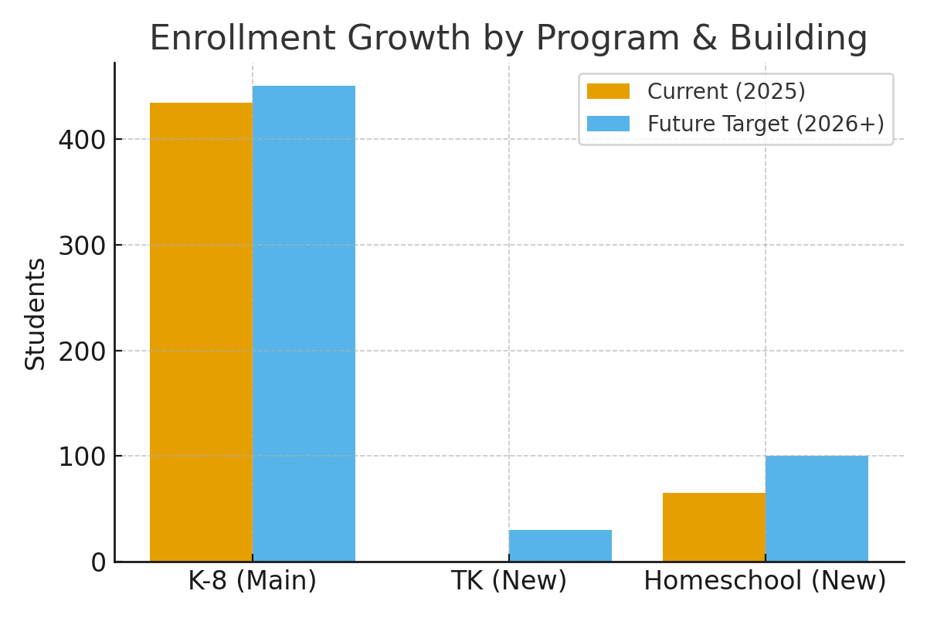
Grade Span | Current (2025) | Future Target (2026+)
K-8 (Main Bldg) | 434 | 450
TK (New Bldg) | 0 | 30
Homeschool (New Bldg) | 65 | 100
TOTAL | 499 | 580

